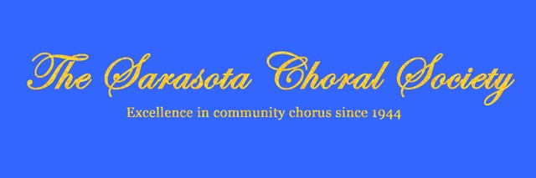

A Letter From The President

To my fellow Sarasota Choral Society members:
This is a wonderful way to do what we do best--get together and sing!

It's also a great opportunity to convey our deepest gratitude and support for the people of Ukraine with donations. Please consider taking part in this meaningful endeavor to hopefully
do our part to help bring peace to the world.

Please read below.

♫Alana Hufford♫, President
Sarasota Choral Society

_____________________________________________________________________________

“Music expresses that which cannot be said and on which it is impossible to be silent.” -Victor Hugo

Friends,

In light of the horrors happening in Ukraine, I find that it is important to raise our voices in support of those who have been silenced.

Will you please join me on April 2nd at 3 pm for a special Concert for Ukraine? The performance will feature several artists from our Sarasota Community, including a community choir (YOU!) that will sing 2 pieces on this hour-long program. The concert will include some readings, prayers, lighting of candles, and an offering will be collected from the audience. The audience is invited to wear blue and gold colors.

This event is organized spontaneously, and sometimes they can be the most meaningful.
Here are the details:

When: Saturday, April 2nd at 3 pm
Where: Church of the Palms
Rehearsals: Thursday, March 31, 6-7 pm / Saturday, April 2nd, 10-11 am. You may choose to attend one OR both rehearsals in music building of Church of the Palms.

Dress rehearsal: 1:30 pm in the Sanctuary

What to wear: White tops, black pants (or skirts). Blue or yellow ties or scarves. I am working on getting blue/yellow "ribbon pins" for all.

Repertoire:

Ukrainian Alleluia by Craig Courtney. Available as a digital download at Beckenhorst Press
https://beckenhorstpress.com/ukrainian-alleluia-satb-digital-download/ (5 copies minimum, organize with others if needed).

Dona Nobis Pacem (round)
https://www.ilcorodelfaro.it/files/452.pdf
Singers must provide their own music, as this is an event that is spontaneous.
We will also sing “Let There Be Peace on Earth” with everyone. Music will be provided at the rehearsal.
Please note – masks are encouraged but will not be required.

Added bonus: Bring a sunflower to the concert to add to our décor.

If you would like to participate as a singer in this event, please email me directly at gbeauchamp@churchofthepalms.org so I may communicate directly with you. Don’t hesitate to share the concert information. Graphics are being created to share more easily.

It is my prayer that our music will bring hope to the people of Ukraine.

Warmly,

Genevieve Beauchamp

